Title or Task: | Computer Basics Quiz    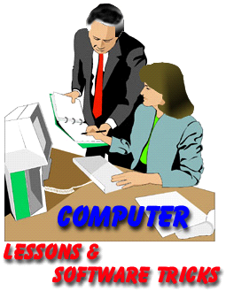
Description: | Can use the internet for information

Files Required
Suitable for Classes: | AIT • Multimedia • Cert II IT • Cert II Bus
Area: | Technology & Enterprise
Teacher: | Mr Peter Faulks
Timeline | 2 hours

Date Due:
Task Brief: | In class lesson

Outcomes:

Items highlighted in yellow are tasks for you to complete
Items in Blue italics are help tips

Computer Basics Quiz

The Four Basic Functions of a Computer
1. Input -- Input devices enable us to get information into a computer. Some
examples include a keyboard, mouse, microphone, scanner, or digital camera.
2. Storage -- There are two types of storage: temporary and long-term. RAM, or random access memory, is temporary, meaning it stores information as you use it, but it is being constantly erased and rewritten as you open and close files.

Long-term storage holds information for as long as you want it. Hard drives, portable hard drives, floppy drives, flash drives, CD’s, and DVD’s are long term storage devices.
3. Processor -- A microprocessor controls the computers’ functions. It can be as small as a dime or larger such as 1-2" , but contains millions of transistors that perform millions of instructions per second. The microprocessor performs these instructions using a three-step process: fetch, decode and execute.
4. Output -- Information that has been processed is communicated back to the user in the form of words, sounds or pictures, and is delivered through
printers, speakers, monitors or other output devices. Sometimes output is
just written back to a storage device.
Computer Basics Quiz Start
Q1. Label the main parts of a computer and various hardware components
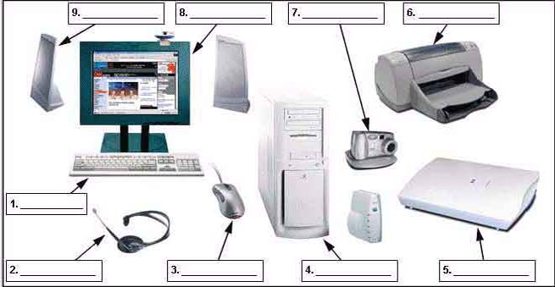

Label these computer parts 10 What is this?
1
2
3
4
5
6
7
8
9

Q2. List the main types of computers
Answer:

Q3. List and describe each function of a computer i.e. Keyboard, Mouse, Monitor
Answer:

Q4. List and describe some storage devices and their basic categories
Answer:

Q5. How do you access system information from the Start Menu?
Answer:
Q6. What is a Jump Thumb or USB Drive?
Answer:
Q7. How do you add shortcut icons to the desktop?
Answer:
Q8. How do you add programs into the start menu?
Answer:
Q9. How do you find out the size of a folder – how many megabytes it
Answer:

Q10. How do you rename a file or folder?
Answer:
Q11. If you delete a file how can you restore it?
Answer:
Q12. How do you adjust the date and time on the desktop?
Answer:
Q13. What are 3 different ways you can access a file or folder?
Answer:
Q14. In Windows Explorer what are 3 ways to select multiple files?
Answer:
Q15. How do you add photos and slide shows to your desktop or screensaver?
Answer:
Q16. How do you change the way the files are displayed in the open dialogue box?
Answer:
Q17. How do you check on the progress of a print job?
Answer:
Q18. How do you change the default printer?
Answer:

Q19. Name the parts of the desktop in the picture below and the function of each.

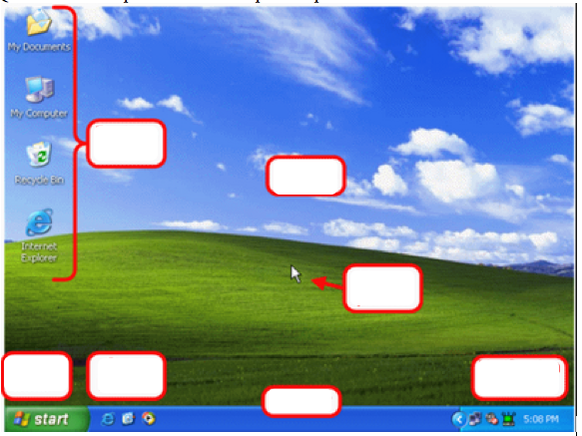

Functions

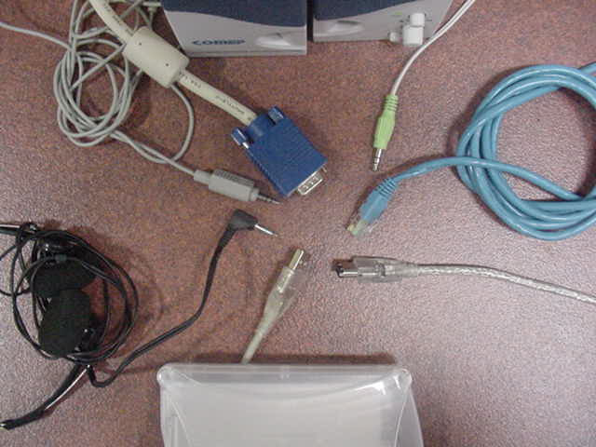
Draw arrows to identify each cable note there may be more than listed

Headphone MiniDIN Video Ethernet (network) Firewire USB Mini Speaker

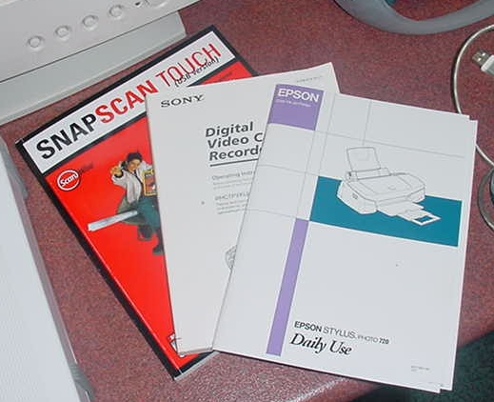
Answer:

Manuals give advice about ….
Identify arrows from labeled text boxes to each hardware component

i.e.

Stereo Speakers

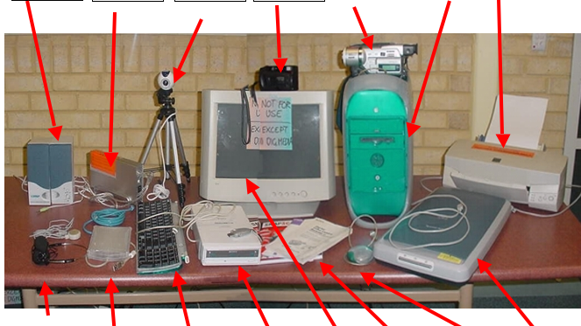

Label the common hardware used in the workplace.

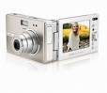 | 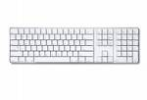 | 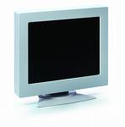 | 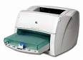
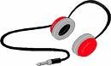 | 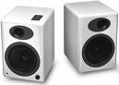 | 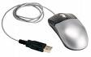 | 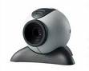
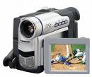 | 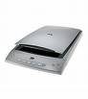 | 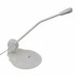 | 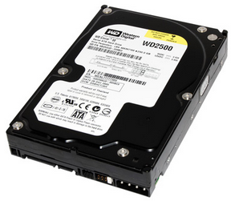
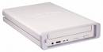 | 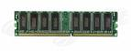 | 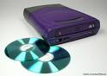 | 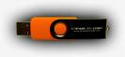

END of QUIZ

